‘Making the invisible visible'
Joanna Neil
University Centre Blackburn College
Lancashire, United kingdom
j.neil@blackburn.ac.uk

Abstract
‘Making the invisible visible’ was practice-led research where audio and visual technologies were used to capture the process of creating, reflecting on and making a piece of creative work. All parts of the documented, and now visible process, became the work; with the captured process being incorporated into the art work itself using innovative technologies. The final piece produced became the sum of its parts. It included what was visually produced as part of the process, as well as captured documentation of what is usually not visible, conversations and thoughts. The auto-ethnographic process enabled observations to be made of a creative practice, gain insight into the creative process and consider the benefits of documenting, reflecting, and using recall techniques. The approach encouraged the adoption of performance type and documentary based practices as reflective practice, with a central question: How can technology best support a more analytical, critically reflective and visible process for creative practices? The project was shared as an on-going process on a personal blog and Community Open Online Course website (COOC). Both spaces enabled the sharing of the project as an open resource as well as spaces in addition to the physical studio to make, reflect and learn.

Keywords
Reflection, dialogic, creative process, digital technologies, OER, auto-ethnographic, narratives

Introduction
This paper explores open practice as a form of Open Education Resource. The practice: the process of making a piece of work from initial idea through to final piece, was fully documented and shared with others as a visible process and documented research project. This paper identifies how the sharing of this making process on two virtual spaces, enabled a construction of an OER and a means to document the making process, which provided an additional studio space: a space to think, work, reflect and construct in. The Joint Information Systems committee considers how ‘OER can be looked upon as a process as well as a set of products. This is because educators need to rethink the way in which they create, use and distribute learning and teaching materials’ (JISC, 2013). Using digital technologies to make the creative process as visible as possible, and sharing this in a virtual space enabled me to view the process as an outsider, and able to be on the outside of the process looking in, in the same way anyone accessing the project as an OER would. At this stage of the project, how others have accessed the project as an OER remains to be assessed, but future developments of the project will focus on how this form of open practice could potentially be a method for learners to explore how documenting and sharing their making process, could enhance and develop their working practices. This approach encourages students to adopt performance type and documentary based practices as a tool for reflective practice with a view that digital technologies can enable a more analytical, critically reflective and visible process for creative practices.

The project
The ‘making the invisible visible’ project was as much about making visible the parts of the creative process which are usually hidden to me as the creator, as it was about making them visible and accessible to a wider audience. Sharing and making the creative process transparent, or open, gives insight into a creative practice and may challenge perceptions about how a piece of creative work is made. The documentation attempted to capture the thinking behind the production and decision making and to go beyond producing a series of ‘how to’ instructional videos. The creation of artworks can seem like a mystical act, an illusion perpetuated by artists who might wish to keep their processes enigmatic with the presentation and exhibition of artworks contributing to this mystery when accompanying text, narratives and titles are selective in giving insight. Revealing the process has been an attempt to de-mystify the creative process and make the thinking and development of a piece of work transparent and accessible. To reveal as much of the process as possible required ways of capturing as much of the making and thinking as possible. Underpinning this was the question of how using digital technologies to capture and document a making process might support and enhance a more critically reflective practice within the creative design process itself for the maker. The technologies; film, voice recording and editing software enabled the following to be explored:
- What does a visible process look like?
- What insight does recording the process give me about my own practice?
- What insight does recording the process give others’ about my own practice?
The process or ‘evidence’ collected was initially stored on desktop files before being minimally edited in film editing software Camtasia and hosted on YouTube and Vimeo. The cloud based platform Evernote was used as a private repository space where voice memos, writing and links to films were held before being published on two different public spaces. The public spaces that were used to make the making process visible were; an established personal blog (Figure 1) and a newly formed Community Open Online Course (COOC) space, initiated and designed by University Centre, Blackburn College colleague Peter Shukie.
Figure 1. The established blog space
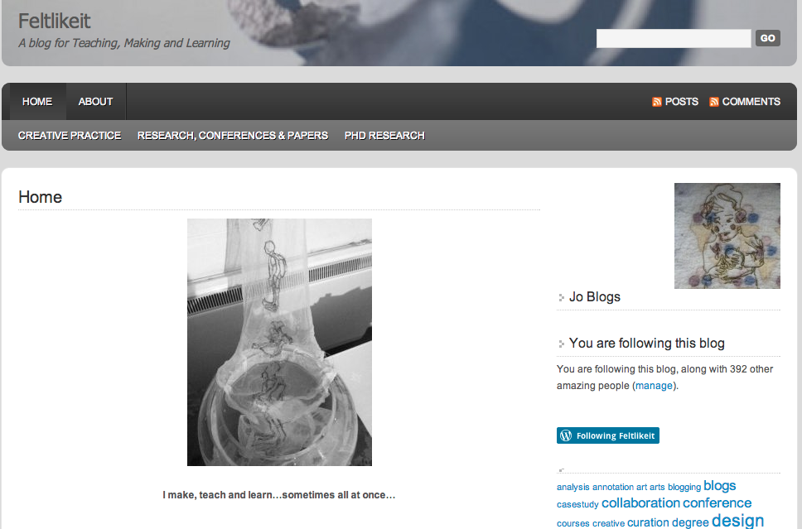
Figure 2. The COOC web space

The blog space was a well-established personal blog space ‘a blog for teaching, making and learning’ where the ‘making the invisible visible’ process was documented within the ‘PhD Research’ category as posts. The blog became a space that gave an informal structure to the process and enabled the process to be presented sequentially with different artefacts juxtaposed together. The first post, ‘The Beginning’ included a podcast of the voice memo, which captured the initial idea and was positioned alongside diary-like writing that had been written a week later, which refers back to the voice memo. The blog allowed these quite fragmented pieces of documented process to be ordered, but at the same time retained some of the original rawness of their construction. Having the blog as a publishing space provided an audience for the documentation process, an outlet for the narrative that was emerging. Documenting the creative process was as much about recording and capturing so that a personal practice could be viewed from the outside, as it was about telling a story to an imagined audience viewing that space.
Posting the documentation of the process as blog posts occurred at the same time that the documentation was being formed as a course on the COOC space. This space, set out to create a hierarchy free environment, where communities of participants; tutors or learners or both can engage with ‘courses’. The interpretation of courses, ‘tutor’ and ‘teaching materials’ is intentionally loose. This provided an ideal forum to organise and share the captured and documented making process. This website provided a structure where insight into a piece of research as well as a creative process could be shared with a potential learner, where they were able to access the documentation, but also encouraged to ask questions and embark on their own creative process to potentially record and share with others.
In comparison to the blog space the COOC environment provided a more formal structure to organise the documented process as series of lessons. This provided an additional space to explore and articulate ideas but also provided an imagined learner as an audience to share with and informally teach. The narrative of the making became blocked into episodes, enabling deeper reflection on what this documentation might be revealing. By considering what it might be revealing to others allowed more insight into what it was revealing to me. The opportunity to publish and share the process ‘documentary’ as a COOC broadened what might be considered as a course or educational experience. This had an impact on me as both producer and learner.
Carole Kirk and Jonathan Pitches University of Leeds Digitalis project 2010-12, examined how capturing performance using film enabled students to reflect more effectively, benefiting their understanding and production for future pieces. Kirk and Pitches (2013, p.3), refer to earlier research by Delahunta and Shaw (2006) where a participant in their study on recording dancers movements, observed that ‘transferring the information into a different medium allows you to see or “re-see” what you’ve done’. For the ‘making the invisible visible’ project this re-seeing occurred on different levels, firstly the re-seeing of the making practice on film or re-hearing thoughts captured as sound recordings, enabled insight into a process usually unseen or unregistered, but on another level the transferring of the captured process onto the blog or COOC space as an OER, enabled a way of re-seeing the process as someone even further outside of the making. Kirk and Pitches think it is important that ‘creative practitioners…experience the performance/artwork as a ‘stranger’’, the recording of practice does allow for the maker to step back and view in. It is also the use of digital technologies that ‘can provide a distancing mechanism, putting the maker into the shoes of the viewer’ (Ibid).
The observation that ‘to be able to stand outside the movement ... could allow you to go back into the movement with new information’ (Delahunta and Shaw (2006) in Kirk and Pitches 2013, p.3) was in the context of observing dance movement, however, movement could be interpreted as any observable act of responding creatively to stimuli. This also accurately describes how the use of the technologies became not only a means to capture and document the process, but also how they interfere with the process. Going back into the process with new information, whether that is a newly found awareness of how the drawing or thinking process, started to not only inform the work, but also form it as well.
Observing the making of an observational drawing provided insight into the length of time spent looking at my drawing compared to the time spent looking at the image used for the drawing. The rapid eye movement between looking at image and newly created image and how this changed over the fifteen minutes of creating it, enabled observations to be made about a personal relationship to the act of drawing and recording, in a more intimate way. Observing the self in the act of making a drawing allowed insight into mark-making, where the eye focuses, makes corrections, adjustments made, pace of working at different points, and the on-going thought process. Recording where the eye is focused made the thought process observable and visible. For Johansson et al (2013) tracking the eye is a way of studying the inner space: an internal representational space for ‘thinking, reasoning and communication’ (p.10). Their earlier research found ‘ striking similarities between participants’ eye movement patterns when they looked at a complex picture…and their eye movements when they later looked at a whiteboard and described this scene from memory’ (ibid p.12). The technology used to record making drawings in the ‘making the invisible visible’ project was basic compared to Johansson et al’s study which used an infrared pupil and corneal reflex imaging system. However, these methods enabled data to be extracted that has the potential to shape further studies into how drawing is taught and reflected on. The drawing process was recorded with a head-camera and these were later observed in film editing software, using markers to apportion time spent on different aspects of drawing activity (Figure 3).
Figure 3. Markers used in Camtasia film editing software to apportion activity in hours: minutes: Seconds: Frame rate (30 frames per second).
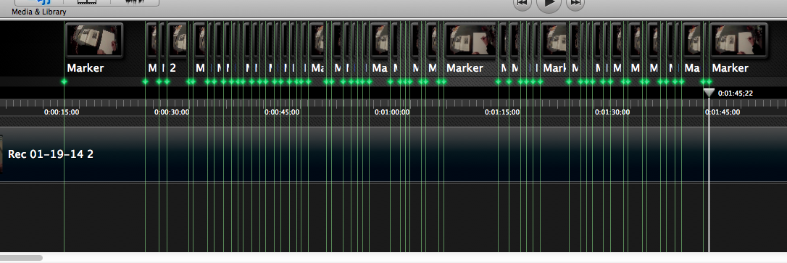
In the first 2 minutes of making a drawing as much time was spent looking at what was being drawn (very short bursts, on average 1.27 seconds), as the time spent drawing, (on average 1.72 seconds). The time spent drawing included ‘visualising’ time; time spent looking at the blank paper. With more sophisticated tools the time spent visualising on blank paper might reveal a similar pattern of eye movement when looking at the image. Time spent visualising, and whether this was used to imagine what was being observed has potential to be explored further. The reflection on the process of making a drawing and the idea of replicating something from memory informed how the work developed, the following is an extract from written notes on the blog ‘I became interested in how repeat tracings or free-machine stitching of the same image is a form of mimicry but that through the process each one turns out differently and evolves.’ (Neil, 2014). Figure 4 Shows images of the development from drawing to repeated imagery stitched on silk, ‘repeated imagery became a rhythm, the free machine technique allowed me to focus on the lines but also respond to the sewing in the same way I would with a pencil on paper. Each image would be different and look slightly different but overall they look assertive in their attempt to look the same’ (Ibid).
Figure 4. Images in the studio of repeated stitched imagery on silk
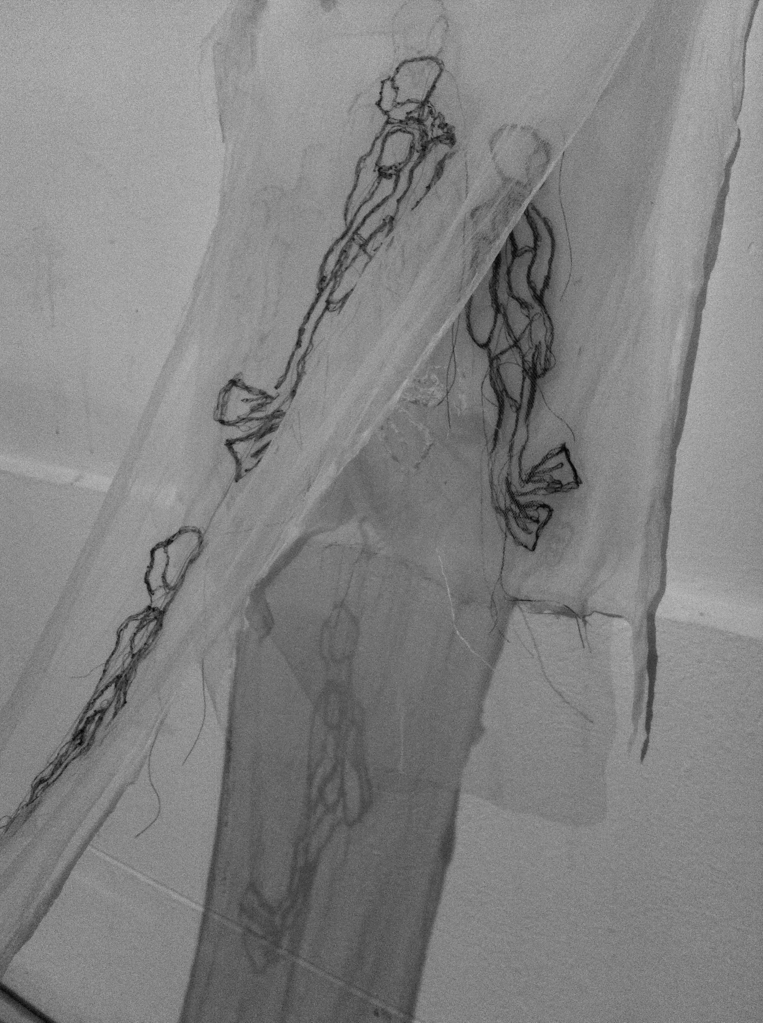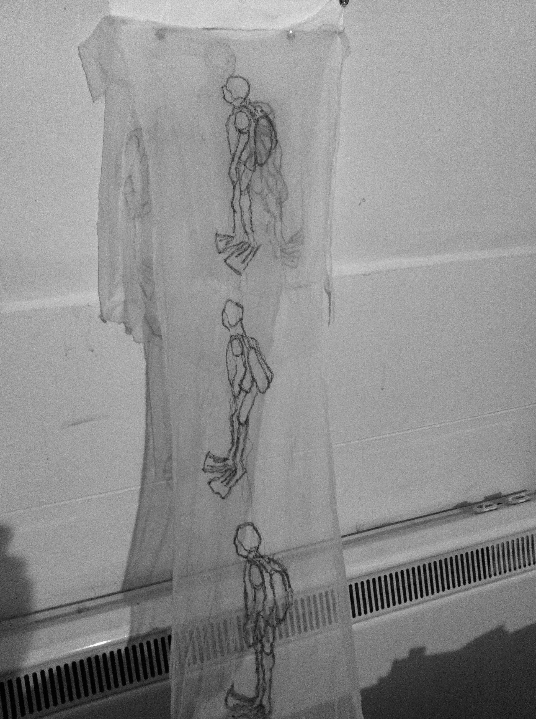
As well as analysing the visual captured process, the documentation revealed a significant emphasis on the importance of internal dialogue that occurred. These were recorded as voice memos or reflective writing and were a combination of reflecting on previously captured work or thoughts and thoughts and ideas of where to go next. There was also a significant amount of dialogue with others throughout the making process. These are elements that are potentially lost in an undocumented making process, but digital technologies enable these to be captured effectively; both audio recording and films of conversations at different stages of the project were made.
A strong element in the project is about what emerged along the way rather than what was pre-designed. The use of digital technologies, the blog and COOC spaces helped to hold the messy parts of the process together like virtual sketchbooks. Compared to a traditional sketchbook the online spaces enabled different things to emerge from the creative process, particularly the ability to document different forms together, recall the information easily and flexibly. The blog space became a sort of portable wall where the process could be organised and take on its own life, a physical, albeit virtual reminder of the studio space. In addition to this a sense of a personal identity emerged from the process, which confused the roles of contributor and learner. This was not an explicit shift of roles but a blurring of role and identity as a contributor. Progress was made through the process of constructing an open resource. Having an awareness of an audience or recipient enabled a more self-reflective, dialogic approach to reflecting on the work as it was evolving.
The blog and COOC spaces are not formal spaces for learning or assessment. The lessons on the COOC were a shared insight rather than explicit about ‘this is what you are being told, ‘this is what you are learning’, ‘this is how you do it’ and ‘this is how you will be measured on how well you can do it’. The blog became a journal that shared a continuous narrative, which was stronger in the way it created a time line with richer juxtapositions of different sources and media and was less about order and structure but more about having a rough sequence of events; the process in one place. Chris Follows (2011) found that when blogs were used by students alongside their creative practice they enabled enhanced communication, made the students practice more visible, introduced open practice and ‘encouraged students to reflect and explore how they operate online’. However Kirk and Pitches (2013, p.15) found limitations with them, ‘ blogs may be easier for students to adopt initially. However, they may ultimately limit opportunities to deepen reflection…as well as restricting students’ personal creativity ’. The use of a blog for the making the invisible visible project was not in itself a reflective tool, however the sharing of reflective activity that had already taken place made the blog a platform for revisiting, re-seeing and stepping outside of the reflective activity as a new viewer. David Brake’s in-depth examination of the bloggers perceived relationship with their audience examines the ‘contradictions and complexities surrounding personal blogging’ (2012 p.1056). How one considers the ‘self’ as audience in the case of reflective writing poses an interesting relationship between online identities and finding a reflective voice.
The research so far indicates that using technologies to document creative processes and how we share this practice, producing OERs that benefit our own practice and others’, has a potential impact on how we teach and learn from the creative process. There are interesting questions to explore such as personal identity through a creative making process, finding a reflective voice and using technologies to stimulate recall, observe and respond to what is often hidden. The OERs in this research are products of a shared and visible process and are potentially powerful teaching and learning devices, revealing the process itself may also have an impact on how we teach aspects of that process.

References
Brake, D.R. (2012), ‘Who Do They Think They're Talking To? Framings of the Audience by Social Media Users’, International Journal of Communication, vol. 6, pp. 1056-1076.
Follows, C. (2011), Striking a balance between practice and open practice? University of the arts London http://process.arts.ac.uk/content/striking-balance-between-practice-and-open-practice (accessed March 19 2013).
Joint Information Systems Committee (2013) A Guide to Open Educational Resources Retrieved February 10, 2014, from http://www.jisc.ac.uk/publications/programmerelated/2013/Openeducationalresources.aspx.
Johansson, R., Holsanova, J. & Holmqvist, K. (2013), Using Eye Tracking Methodology as a Window to Inner Space. In: Paradis, C., Hudson, J. & Magnusson, U.: Conceptual Spaces and the Construal of Spatial Meaning. Empirical evidence from human communication. Oxford University Press, pp. 9–28.
Kirk, C. & Pitches, J. (2013), ‘Digital reflection: using digital technologies to enhance and embed creative processes’, Technology, Pedagogy and Education, pp. 1-18.
Neil, J., (2014, February 25), Iteration. Blog post http://feltlikeit.wordpress.com/2014/02/25/iteration/

